# CS 255 System Design Document Template

This template lays out all the different sections that you need to complete for Project Two. Each section has guidance to prompt your thinking. You will need to continually reference the interview transcript as you work to make sure that you are addressing your client’s needs. There is no required length for the final document. Instead the goal is to complete each section based on what your client’s needs are. Remove this note when you are finished, and replace all bracketed text with the relevant information.

## UML Diagrams

### UML Use Case Diagram

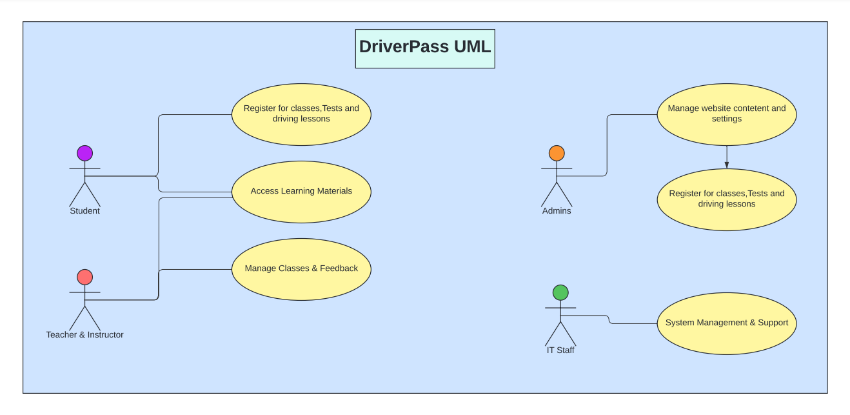

### UML Activity Diagrams

*UML Activity Case on Student Login/Registration*

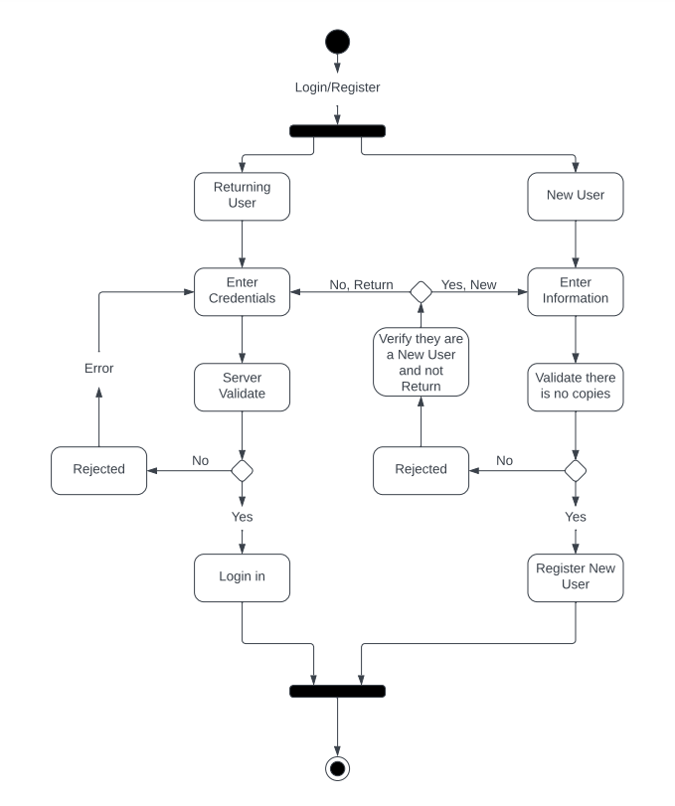

*UML Activity Case on Student Class Registration*

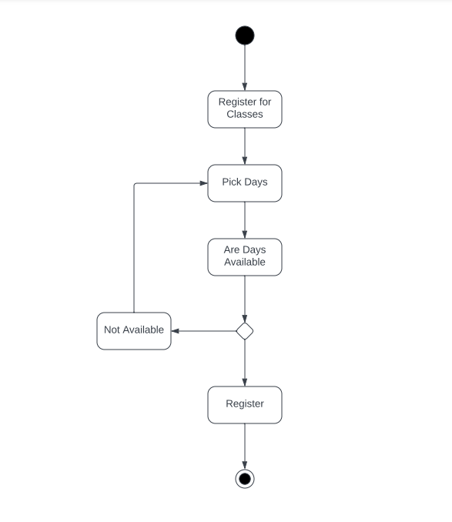

### UML Sequence Diagram

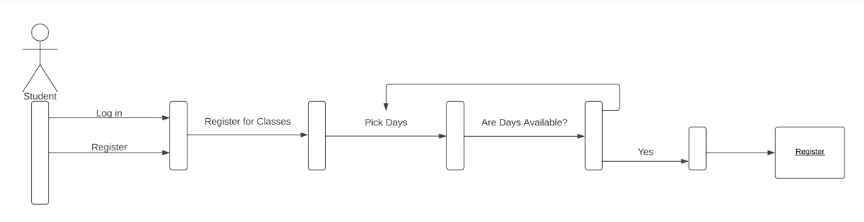

### UML Class Diagram

## Technical Requirements

Based on what DriverPass is asking us to do this system should be able to run on any laptop, desktop or mobile device. It should be a system that does not require a lot of processing power. It should also be simple enough that anyone can and should be able to use it without confusion or struggling to get around the site.